Table of Contents

Specific Aim 3 2

Rationale and Background 2

Murine Placental Development and Physiology 2

Figure 1: Diagram representing the mouse placental cell types and zones 2

Obesity in Pregnancy 3

Effects of Obesity on Placental and Fetal Development 3

Effect of Obesity on Placental Nutrient Transporters 3

Glucose Transporters 3

System A Amino Acid Transporters 3

Fatty Acid Metabolism 3

Effect of Obesity on Placental mTORC1 Function 3

Effect of Obesity on Placental Endocrine Function 3

Effect of Obesity on Offspring 3

Experimental Design 3

Figure 3: Diagram representing the breeding method to generate the knockout placenta 4

Methods 5

Food Intake 5

Body Composition 5

Sacrifice and Tissue Collection 5

Insulin Tolerance Test 5

Real time qPCR 6

Genotyping 6

Western Blotting 6

Histology 6

Expected Results 6

Aim 3.1: How does placental mTORC1 activity affect placental development, fetal growth, and fetal survival? 6

Aim 3.2: How does placental mTORC1 hyperactivation affect the expression of placental nutrient transporter expression? 7

Aim 3.3: How does mTORC1 signaling affect placental endocrine function? 7

Aim 3.4: How does placental mTORC1 hyperactivation affect offspring survival, weight, body composition, and insulin sensitivity? 7

Potential Pitfalls and alternate Approaches (Aims 3.1-3.4) 7

# Specific Aim 3

**Elucidate the consequences of placental nutritional stress driven by mTORC1 hyperactivation on placental role.** To model excessive nutritional stress, such as that of maternal obesity, I will use a genetic model of mTORC1 hyperactivation in the placenta using a trophoblast-specific driver. With this model, I will determine placental hormone production and evaluate nutrient transport, along with offspring metabolic health.

# Rationale and Background

## Murine Placental Development and Physiology

The definitive structure of the mouse placenta is (Malassine *et al.*, 2003). The placenta encompasses two sides, an arc-shaped surface facing the maternal side and another flat surface facing the fetal side (Georgiades *et al.*, 2002). The mouse placenta has three distinct compartments, a decidual maternal zone which is the outermost compartment, a fetal-derived junctional zone that mediates placental endocrine function, and a fetal-derived labyrinth zone that comprises the majority of the placenta and is the main site for nutrient and gas exchange (Woods *et al.*, 2018). Three exchange barriers exist moving inwards from the decidua to the fetal compartment including two syncytiotrophoblast layers (in the labyrinth layer) and one fetal endothelial cell layer (Georgiades *et al.*, 2002). The two syncytiotrophoblast barriers comprise the microvillous membrane facing the maternal circulation and the basal membrane facing fetal circulation (Brett *et al.*, 2014). Figure 1 represents the mouse placenta (Bronson & Bale, 2016).

At midgestation, placental invasion of the maternal uterine cavity occurs to allow maternal blood flow into the placental cavity (Malassine *et al.*, 2003; Woods *et al.*, 2018). This invasion permits direct nutrient uptake from the maternal circulation to the fetus through the placenta. Prior to this invasion, the embryo acquires nutrients from the yolk sac, the initial placental structure that absorbs nutrients from maternal circulation (Malassine *et al.*, 2003; Woods *et al.*, 2018).

### Figure 1: Diagram representing the mouse placental cell types and zones

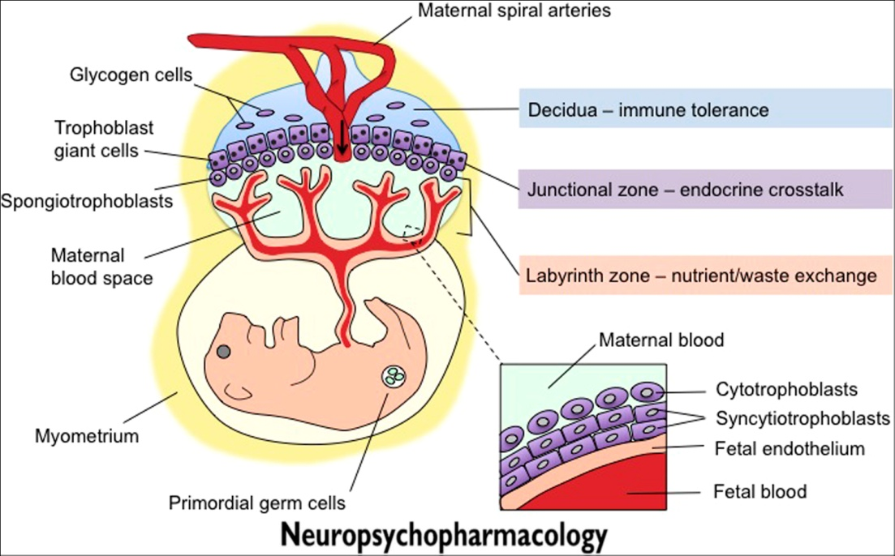

*Neuropsychopharmacology Reviews* (2016) **41**, 207-218;

doi:10.1038/npp.2015.231

## Obesity in Pregnancy

## Effects of Obesity on Placental and Fetal Development

## Effect of Obesity on Placental Nutrient Transporters

### Glucose Transporters

### System A Amino Acid Transporters

### Fatty Acid Metabolism

## Effect of Obesity on Placental mTORC1 Function

## Effect of Obesity on Placental Endocrine Function

## Effect of Obesity on Offspring

# Experimental Design

To determine if the effects of mTORC1 hyperactivation on the placenta and the fetus, we will develop a placenta-specific *Tsc1* knockout (KO) model. To isolate placental from fetal and maternal mTORC1 signaling, our knockout model will ablate Tsc1 conditionally in the placenta. To my knowledge, this is the first time such a model has been generated. To generate the *Tsc1*-KO, we will use the Cre-loxP recombination technology. We will leverage the fact that placental tissue is primarily fetal derived, so the genotype of the offspring will dictate the genotype of most of the placenta. The breeding scheme is represented in Figure 3. First, female mice with homozygously flanked exon 2 of *Tsc1* will be crossed with a male having placental driver *Cyp19a1-CreTg/+* (Wenzel & Leone, 2007).This *Cyp19a1-Cre* has been also used elsewhere to generate a placental knockout model (Wieczorek *et al.*, 2019). This cross will generate wild-type (WT) and heterozygous (Het) offspring at a 1:1 ratio. The expected timeline between this first breed and the second one is 9-12 weeks. The offspring of this first cross will be bred (WT x Het) to generate the parental strains for this experiment. Briefly, this cross will yield a combination of knockout *Tsc1* fl/fl;*Cyp19a1-CreTg/ +*, conditionally heterozygous *Tsc1* fl/+;*Cyp19a1-CreTg/+* , and wild-type *Tsc1* fl/fl ; *Cyp19a1-Cre* +/+ , *Tsc1* fl/+ ; *Cyp19a1-Cre* +/+ , *Tsc1* +/+ ; *Cyp19a1-Cre* +/+ , or *Tsc1* fl/fl ; *Cyp19a1-Cre* Tg/+ (no Cre transgene) at an expected ratio of 1:2:5 with the knockout and wild-type (*Tsc1* fl/fl ; *Cyp19a1-Cre* +/+ only) animals only being used for further breeding. The expected timeline for this second cross to generate mature offspring capable of breeding is also 9-12 months. The final parental breed of WT x KO will generate our placental KO model. The final offspring generated from the next generation will all have the floxed allele with the Cre (KO) or without (WT). The offspring generated from the last main parental breed will either be WT with intact placentas or knockout with placental KO and a phenotypically WT embryo.

### Figure 3: Diagram representing the breeding method to generate the knockout placenta



# Methods

## Food Intake

Food will be weighed when the treatment starts and throughout the experiment. The weight of the dam’s food will be recorded three times weekly every Monday, Wednesday, and Friday. Food will also be weighed at delivery for the dam. Food will be topped off to ~400g weekly every Friday. Food intake will be calculated as:

If the dam is single housed or with nursing pups:

(the new added total food weight - the last measurement’s food weight) / # of days between measurements

If more than one adult mouse is in the cage (when the male is breeding in the same cage, or when weaned offspring are housed together), food intake will be calculated as follows:

(the new added total food weight - the last measurement’s food weight) * #of days between measurements / sum of days spent by each mouse in that cage between measurements

## Body Composition

Mice will be weighed by using dynamic weighing to capture accurate weight using a digital scale. The weight will be recorded along with the mouse ear tag number. The mouse will be gently placed in the MRI tube with the plunger slightly compressing along the mouse body to ensure it cannot move during the measurement. Fat, lean, free water and total water mass (g) will be recorded for each animal.

## Sacrifice and Tissue Collection

Dams of groups E14.5 will be sacrificed on the respective dates based on their treatment group. Dams will be anesthetized using an isoflurane vaporizer. Toe punches will be performed to ensure that the mouse is under anesthesia. A midline incision of the skin from the rectum to the diaphragm will be made while the mouse is still alive and anesthetized using the vaporizer. The uterine horn will be exposed and placental and fetal excision will begin in order along the uterine horn starting from the side (closer to the ovaries). The amniotic sac for each pup will be ruptured using fine scissors. The placenta will be detached from the maternal tissue and the umbilical cord then weighed and immediately snap frozen or cryopreserved and in paraffin for future molecular and histological studies. Fetuses will be weighed after removal from the amniotic sac then they will be immediately sacrificed by decapitation using surgical scissors. After the complete extraction of tissue, dams will be euthanized while under anesthesia by cardiac exsanguination.

Offspring of dams that will be allowed to deliver and nurse (groups of E21.5) will be dissected at 6 weeks of age. Offspring will be first anesthetized using isoflurane drop jar. Offspring will be sacrificed using isoflurane drop jar. Cervical dislocation will be performed as a secondary measure to confirm euthanasia. We will dissect the offspring fat pads by a midline incision of the skin from the rectum to the diaphragm, extract inguinal and gonadal white adipose tissue. Inguinal white adipose tissue (iWAT) will be collected from the mouse right side first by pulling the peritoneum away from the skin. Inguinal fat will be carefully extracted, weighed then snap frozen in liquid nitrogen for further molecular studies. Right gonadal white fat tissue (gWAT) will be collected next by scraping the fat along the gonads (ovaries or testis), weighed, and then snap frozen in liquid nitrogen in 2ml tubes. The fat pads will be stored at a temperature of -80C.

## Insulin Tolerance Test

Weaned offspring in groups water or dexamethasone till delivery from cohort A (pre-gestation) and cohort B (at conception) will undergo an insulin tolerance test (ITT) being challenged with 1 U/kg body weight after a 6-hour fast with *ad libitum* access to water. The effects of antenatal glucocorticoid exposure on offspring adolescent insulin sensitivity will be determined. Briefly, after the fast, the tail will be cut to allow for blood sampling via AccuCheck Advantage Glucometer. Tail vein blood will be immediately measured at 0minutes after the 6-hour fast to denote fasting blood glucose. Mice will be injected by a syringe into the interperitoneal cavity with the appropriate insulin dosage. The timer will be set as to allow for blood collection every 15 minutes. Blood will be collected at 5, 30, 45, 60, 75, 90 and 120 minutes after injection. After the ITT is done, mice will have *ad libitum* access to normal chow diet and water again. These data will be analyzed by mixed linear models of glucose at each time point.

## Real time qPCR

Using the placental tissues collected from the dams, we will assess RNA expression of macronutrient transporters and endocrine hormones. RNA samples will be prepared from the mouse tissues using the PureLink RNA Mini Kit. Briefly, tissues will be cut to ~50mg samples that will be homogenized and treated to collect the RNA. The RNA will be quantified using a nanodrop. Later, first strand cDNA will be synthesized from the purified RNA samples using High Capacity cDNA Reverse Transcription Kit. The cDNA samples will be diluted and added to the clear 384 well plate in triplicates. A Primer/SYBR Green mix will be prepared for each primer. Briefly, we will use sequence-specific primers to amplify GLUT1, GLUT3, GLUT4, SNAT1, SNAT2, SNAT4, LPL, GDF15 and IGF-II using primer pairs (forward and reverse). This will allow us to assess the overall endocrine and transport function of the placentas of Dex- and Water-treated dams. PCR will be performed for *Sry* to determine the sex of the placentas/fetuses using a piece of the placenta or fetal tails, respectively.

## Genotyping

Maternal and fetal genotyping will be conducted to confirm the GR KO or WT genotype of the dams and fetuses/placentas. To genotype the dams, DNA extraction from tail clips will be done. qPCR analysis of the *Nr3c1* gene will be conducted to determine gene expression. For fetal/placental genotyping, fetal tail will be entirely clipped for DNA analysis along with a section of the placenta to confirm expression of *Nr3c1.*

## Western Blotting

Using the placentas collected at E14.5, mTORC1 activity will be assessed. Validation of glucocorticoid receptor ablation will be validated from collected placentas. Briefly, a portion of the sample will be boiled and loaded into different wells with a ladder control. Proteins will transfer to nitrocellulose overnight. The matrix will be stained for total protein using Revert total protein and scanned by LiCOR to normalize against total protein. Samples will be incubated with the primary then the secondary antibodies. Briefly, antibodies against total and phosphorylated mTORC1 targets (S6K, 4EBP1, S6) and regulators (Akt, IRS and TSC2) and antibodies against GR will be used.

## Histology

Placentas collected from control and experimental at E14.5 will be embedded in paraffin and stained at the Rogel Cancer Center’s Tissue and Molecular Pathology. Slides will be blindly assessed for labyrinth thickness and area.

Expected Results

## **Aim 3.1:** How does placental mTORC1 activity affect placental development, fetal growth, and fetal survival?

## **Aim 3.2:** How does placental mTORC1 hyperactivation affect the expression of placental nutrient transporter expression?

## **Aim 3.3:** How does mTORC1 signaling affect placental endocrine function?

## **Aim 3.4:** How does placental mTORC1 hyperactivation affect offspring survival, weight, body composition, and insulin sensitivity?

# Potential Pitfalls and alternate Approaches (Aims 3.1-3.4)